**DAILY ASSESSMENT FORMAT**

|  |  |  |
| --- | --- | --- |
| **DATE** | **20/05/2020** | NAME sampatkumar n m |
| **COURSE** | TCSiON | USN **4AL19EC401** |
| **TOPIC** | 1.**Ace Corporate interview**  **2.Learn Corporate Etiquette**  **3.Write effective Emails** | **SEM 4th sem.A sec**  **sections** |
| **Github Repository** | Sampatkumar1 |  |

**FORENOON SESSION DETAILS**

**Image of session**

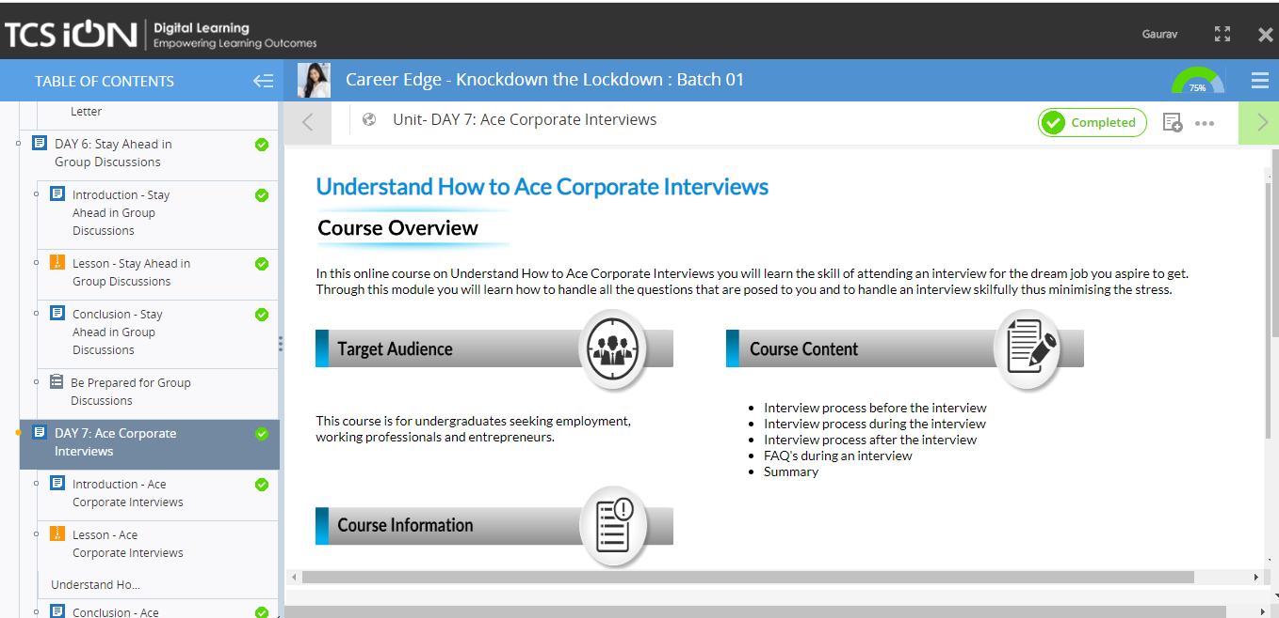

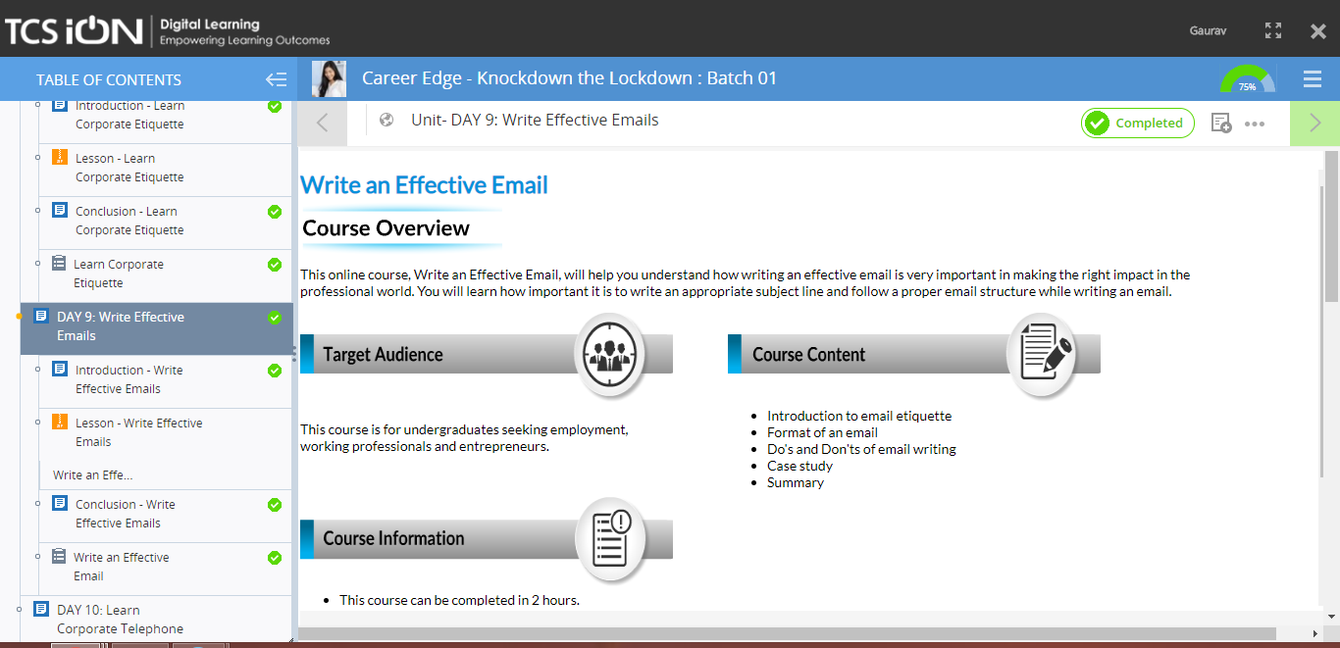

**REPORT : Topic 1 –Ace Corporate interview**

**What is interview:**

* **Interview is a widely used process of screening applicants for jobs.**
* **It provides the most direct information about a candidate, his/her skills, backgrounds and personality type.**

**Some DO’s and DON’T’s should be remember before an interview**

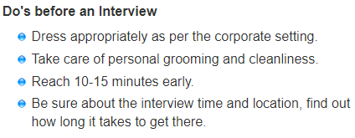

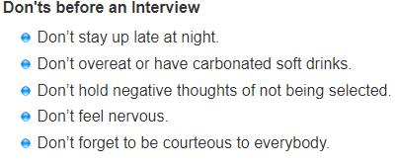

**Major preparations for an interview:**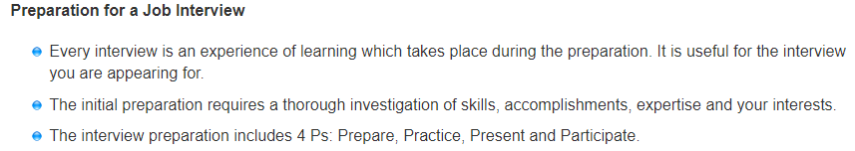 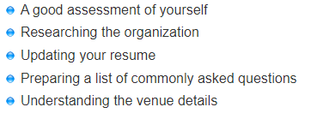

**DO’s and DONT’s during an interview:** 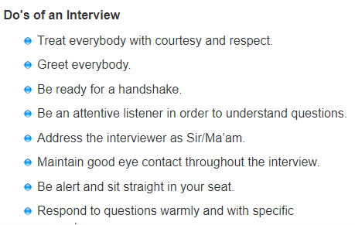

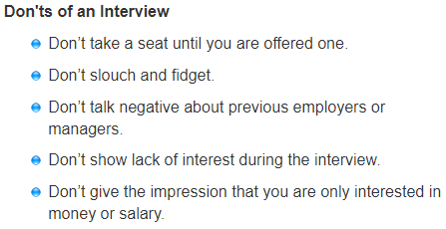

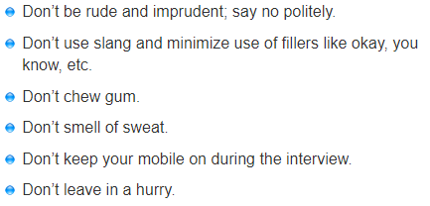

**This topic also covered that,**

* **Men’s and Women’s Interview Attire**
* **Negotiation situations**
* **Techniques required of a good negotiator**
* **Tips to handling a negotiation**

**Topic 2 : day8- Learn Corporate Etiquette.**

**Glimpse of studies from this topic:**

* **Rules to be followed in Business environment**
* **The way we treat people and our behaviour at workplace**
* **Maintaining a neat cubicle is expected from all people on the workplace**

**Topic 3: day 9- Writing an Effective E-mail:**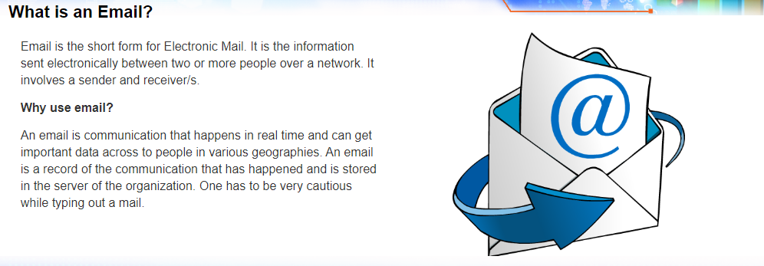

**Basic DO’s and DONT’s to be taken consideration while writing an E-mail:**

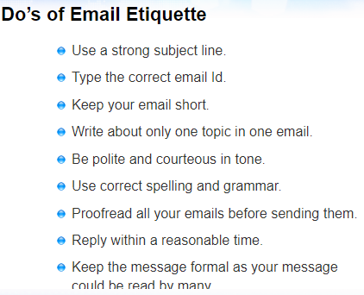

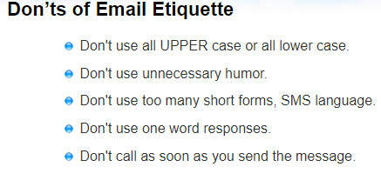

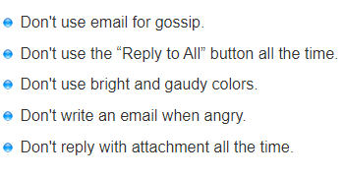

**AFTERNOON SESSION DETAILS**

|  |  |  |  |
| --- | --- | --- | --- |
| **DATE** | **20/05/2020** | **Name** | **Sampatkumar n m** |
| **COURSE** | **Python for machine learning by great learning and morsh python** | **USN** | **4al19ec401** |
| **Topics** | **Data Structures of python(Hands On)** | **Sem and section** | **4th sem.A SEC ECE** |
| **Github repository** | **Sampatkumar1** |  |  |

**Images and report of the session:**

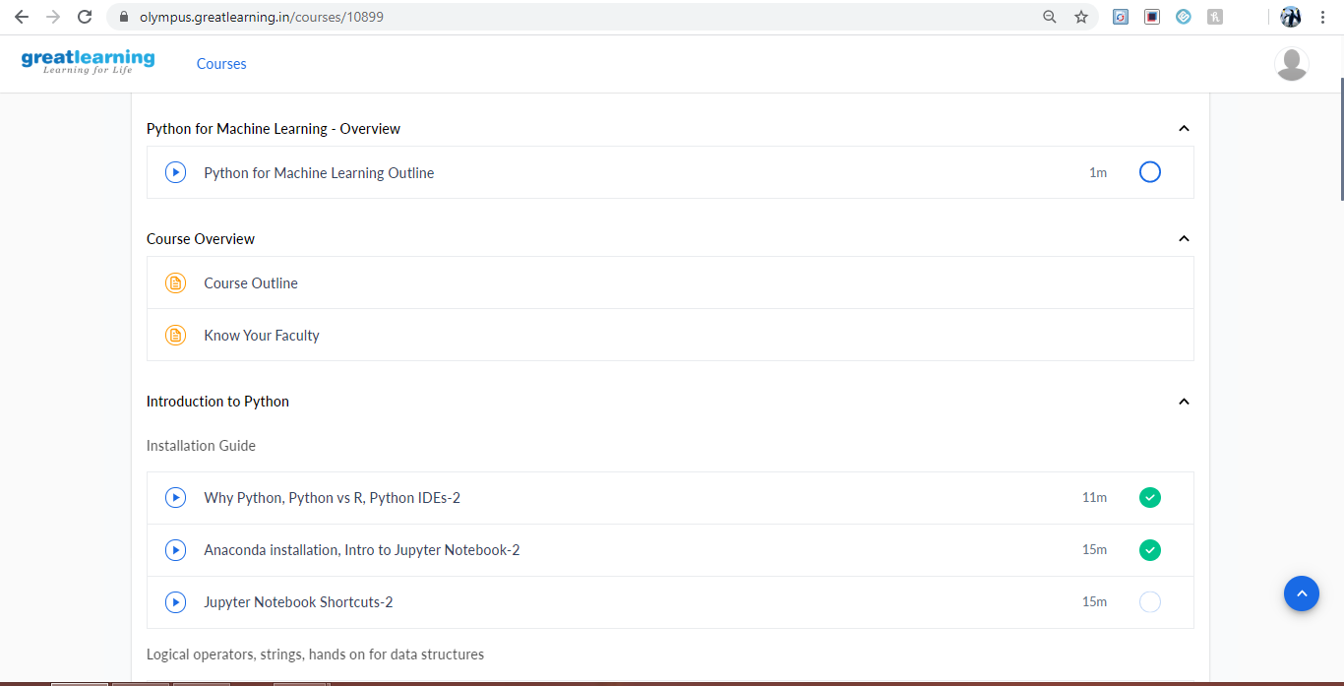

**Introduction to Data Structures in python:**

**The major Data structure of python is:**

1. **Lists**
2. **Tuple**
3. **Dictionary**
4. **Sets, etc.**

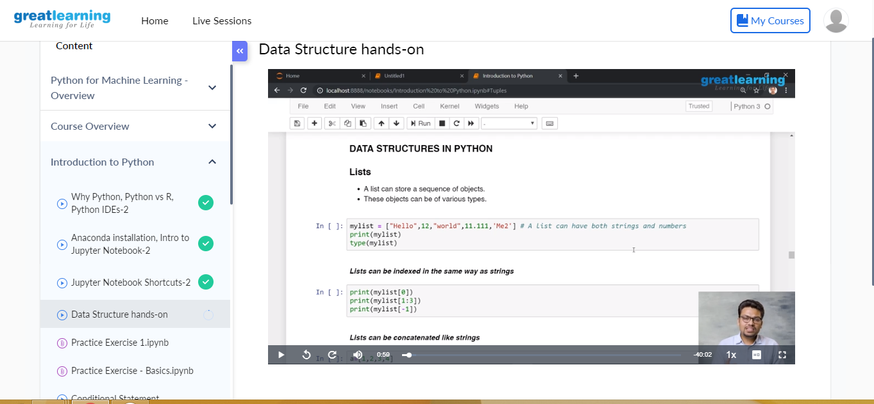

**LIST:**

**A list can store sequence or objects**

**Those objects can be various types,**

**Operations performed on string:**

1. **Concatenation**
2. **Length of list**
3. **Deletion of data from list**
4. **Poping the data**
5. **Max and Min element of list**
6. **Append and Extend the List**
7. **Sorting**
8. **Reassigning**

**Etc.**

**Tuple:**

**It is similar to List, but can’t be appended or extended.**

**It is immutable**

**Elements can’t be edited once assigned.**